Introduction to Quantum Computing – Advanced Linear Algebra - Homework 2 (20 points)

1. What is the inner product of the two vectors below? (5 points)

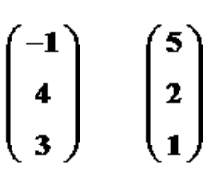

2. Find the length of the vector (3, 4) and show your work for partial credit. (5 points)

3. Find all of the eigenvalues for the matrix below (6 points).



4. Find the corresponding eigenvector for the eigenvalue which is negative (4 points)